**Report No.2: Software Project Management Plan (SPMP)**

# 2.1. Problem Definition

## 2.1.1. Project Name

The formal and official name for this Capstone Project is Rental House Finding System. The product name is “ihouse.vn”, but it might be changed in developing process.

## 2.1.2. Problem Abstract

After doing research and survey, the authors of this product realized that it’s necessary to build a system for Vietnamese users to find a house for lease which is high on demand.

The need for such services is really high. There are currently some other products providing quite the same services, but all have their own advantages and disadvantages. The purpose of this project is to create a product that overcomes all those disadvantages and becomes the useful and effectively for finding a house for lease.

Once completed, the product must possess the following characteristics:

* Friendly interface, easy to use, can be used by all levels of Internet users.
* Posting a new topic is simple and quick.
* Having a good initial database with a considerable amount of information about house for lease.
* Searching function support many options such as price, address, suggestions, full text search.
* The topics about house for lease are clear, detailed and reliable.

## 2.1.3. Project Overview

### 2.1.3.1. Current System

There is no current system; the system is built up from the ground.

### 2.1.3.2. Proposed System

The main system will be a website. There will be mobile applications running on popular operating systems as well.

The system will provide the following main features in front-end:

* Everyone can visit the site and search houses for lease.
* Register new account.
* View profile of users, and house posted by users.
* Compare between 2 houses.
* Authenticated users can post a new topic about house for lease or share.
* Automatic update house status.
* Add house to favorite list.
* Using Facebook account to comment.
* Users can update their profile such as display name, avatar, etc.
* Users can update and renew their house.
* Search function:
* Full text search with Filters
* Search by suggestion
* Some popular social networks will be integrated into the system

The back-end will allow the administrators to manage the most important activities as well as information on the site.

* Admin can manage categories.
* Admin can manage locations in the system: add, edit, and delete locations.
* Admin and MOD can manage post.
* Admin can manage payment.
* Admin can manage MOD accounts.

### 2.1.3.3. Boundaries of the System

The system under development of this Capstone Project will include:

* The complete website
* All the process documents involved

### 2.1.3.4. Development Environment

Below is the list of hardware and software requirements needed for development environment:

#### Hardware requirements:

* Personal computers for developing with the minimum configuration: 2 Gb of RAM, 50 Gb of hard disk, Pentium dual core 2.0 GHz.
* A server computer for testing with the minimum configuration: 2 Gb of RAM, 50Gb of hard disk, Core 2 Duo 2.0 GHz.

#### Software requirements:

* Operating system: Windows XP , 7/Windows Server 2008
* Web Server:
* Framework: ASP.NET MVC3
* IDE: MS Visual Studio 2010 SP1
* DBMS: MS-SQL 2008
* Source Control: SVN
* API: GoogleMapsAPIv3, Facebook API

# 2.2. Project organization

## 2.2.1. Software Process Model

The process model used for developing this project is Waterfall model.

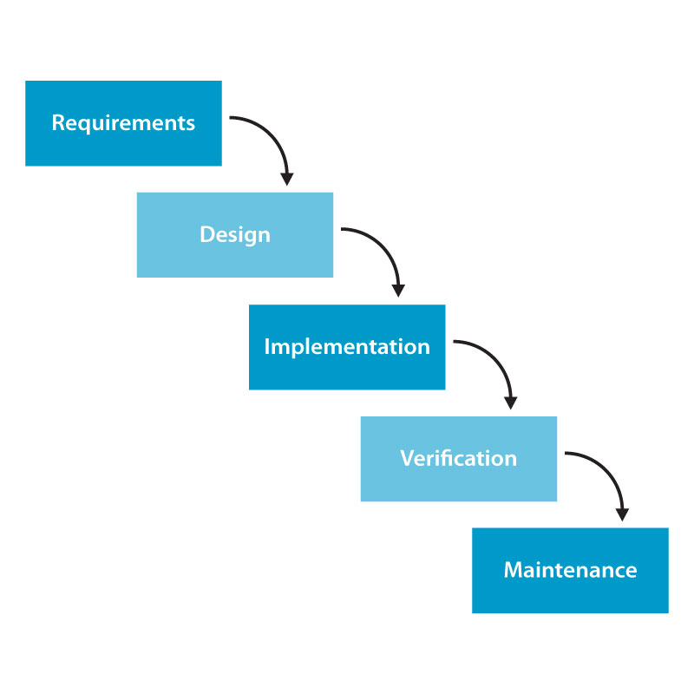

All the phases in the waterfall models are included in the scope of this project and are the responsibilities of the team.

## 2.2.2. Roles and Responsibilities

|  |  |  |  |
| --- | --- | --- | --- |
| No | **Full name** | **Role** | **Responsibilities** |
| 1 | Nguyễn Việt Nam | PM, Designer | * Create project plan * Managing process * Support create document * Creating high-level design and coding framework * GUI Design * Unit testing |
| 2 | Cao Quốc Hưng | Tech Lead, Developer | * Support GUI Design * Designing database * Coding * Unit testing * Managing configuration * Deployment |
| 3 | Trần Thị Bích | Tester, BA | * Clarifying requirements * Support create document, report * Creating test plan and system test cases * System testing |
| 4 | Võ Hoàng Việt | Developer | * Managing documents * Create documents, reports * Support GUI Design * Coding * Unit testing |
| 5 | Nguyễn Tiến Chung | Developer | * Support create document, report * Coding * Unit testing |

## 2.2.3. Tools and Techniques

* Front-end technologies: ASP.NET MVC3, MS-SQL, Ajax, jQuery, Google Map API, Facebook API, SMS Web Service
* Tools: MS Visual Studio 2010 SP1, MS-SQL 2008, MS Office 2007, Adobe Photoshop CS6.
* Architecture and design patterns: MVC

# 2.3. Project management plan

## 2.3.1. Tasks:

### 2.3.1.1 Task 1: Create Project Plan

#### Description

Create Project Plan: prepare plans for Capstone project including: Time, Resource…

#### Deliverables

In the first stage, plan is about all overview of project. Divide project into small stages with corresponding duration.

After unifying all stages of project, must create plan for each stage: time, scope, resource…

Deliver project plan before 13th Jan, 2013

#### Resources Needed

#### All members must discuss about plan, to ensure that each stage fits time, resource of project.

Duration: about 1 week.

#### Dependencies and Constraints

None

#### Risks

None

### 2.3.1.2 Task 2: Create Software Requirements Specification

#### Description

Create Software Requirement Specification (SRS) document

#### Deliverables

#### Software Requirement Specification included all Use Cases of Software product. It can be update during project, if necessary.

Deadline: 27th Jan, 2013

#### Resources Needed

#### Human: 5 persons

#### Duration: 2 weeks

#### Dependencies and Constraints

None

#### Risks

Due to time constrain, the team cannot make a deep research and wide survey to collect information about end-user’s needs. Almost requirements come from team members, conflicts may happen regularly.

### 2.3.1.3 Task3: Design Database

#### Description

Create database design (logical and physical)

#### Deliverables

#### Logical database design: all tables and their relationship.

#### Physical database design: database in SQL Server 2008

#### Deadline: 3rd Feb, 2013

#### Resources Needed

#### Human: 3 persons

#### Duration: 1 week

#### Dependencies and Constraints

Depends on the completion of SRS

#### Risks

SRS may not be detailed enough to capture the business rules, causing the database design to be inappropriate or will be changed much in the future.

### 2.3.1.4 Task4: Create Software Design Description

#### Description

Create Software Design Description: Architecture design, detailed design, diagrams and design specification

#### Deliverables

Deadline: 17th Feb, 2013

#### Resources Needed

#### Human: 5 persons

#### Duration: 2 weeks

#### Dependencies and Constraints

Depends on the completion of SRS

#### Risks

Risks may include choosing inappropriate architecture and design patterns, causing the system hard to maintain, or causing high coding efforts

### 2.3.1.5 Task5: Layout Design

#### Description

#### Design GUI for all interfaces of website.

#### Deliverables

HTML layout and CSS files

Images of all GUI

Deadline: 24th Feb, 2013

#### Resources Needed

#### Human: 3 persons

#### Duration: 1 week

#### Dependencies and Constraints

None

#### Risks

None

### 2.3.1.6 Task6: Coding

#### Description

Implement the system to reflect the requirements

Output: Source code of the project, unit test reports

#### Output

Source code of the project, unit test reports

#### Deliverables

Executable programs and source code before 17th Mar, 2013

#### Resources Needed

#### Human: 5 persons

#### Duration: 5 weeks

#### Dependencies and Constraints

Finish of SRS, SDD, and Database design

#### Risks

Lack of Technical knowledge

Lack of experience in project management

Lack of skill to find and fix bug

Unit test may not be performed thoroughly causing spending more efforts in system test phase

May lack of time to implement all the requirements

### 2.3.1.7 Task7: Create System Test Cases

#### Description

Create system Test cases, follow SRS

#### Deliverables

Deadline: 31st Mar, 2013

#### Resources Needed

#### Human: 1 person

#### Duration: 2 weeks

#### Dependencies and Constraints

Finish SRS

#### Risks

Lack test cases

### 2.3.1.8 Task8: Execute Unit testing

#### Description

#### Developer execute unit testing, follow System test cases

#### Deliverables

Deadline: 1stDec, 2012

#### Resources Needed

#### Human: 4 persons

#### Dependencies and Constraints

#### Finish coding process

Finish System Test cases

#### Risks

Lack of test cases

Lack of testing skill

### 2.3.1.9 Task9: System Test

#### Description

Perform system test for the system

Output: System test report

#### Deliverables

Deadline: 14th Apr, 2013

#### Resources Needed

#### Human: 5 persons

#### Duration: 2 weeks

#### Dependencies and Constraints

Finish Coding

Finish System Test cases

Finish Unit testing

#### Risks

Lack of professional testers in team

Developers are also responsible for system testing, which may lead to compromise

Lack of skill on inputting data to test

Lack of skill in using test tool to test performance of website

### 2.3.1.10 Task10: Deployment

#### Description

Deploy the system to the Internet

Output: Running website with domain and hosting

#### Deliverables

#### Before 18th Apr, 2013

#### Resources Needed

#### Human: 2 persons

#### Duration: 3 days

#### Dependencies and Constraints

Coding and system test are finished, initial data is inputted

#### Risks

None

### 2.3.2. Task Sheet: Assignments and Timetable

**🡪 Anh Babe xem lai cai nay nhe.**

### 2.3.3. All Meeting Minutes

|  |  |  |  |
| --- | --- | --- | --- |
| **Subject** |  | **Date** |  |
| **Facilitator** | Detech Building | **Time** |  |
| **Location** | 8 - Ton That Thuyet Street, Cau Giay District | **Scribe** |  |
| **Attendees** |  | | |
| **Absent** |  | | |
| **Content** |  | | |

# 2.4. Coding Convention

# 2.5. Other material (if any)